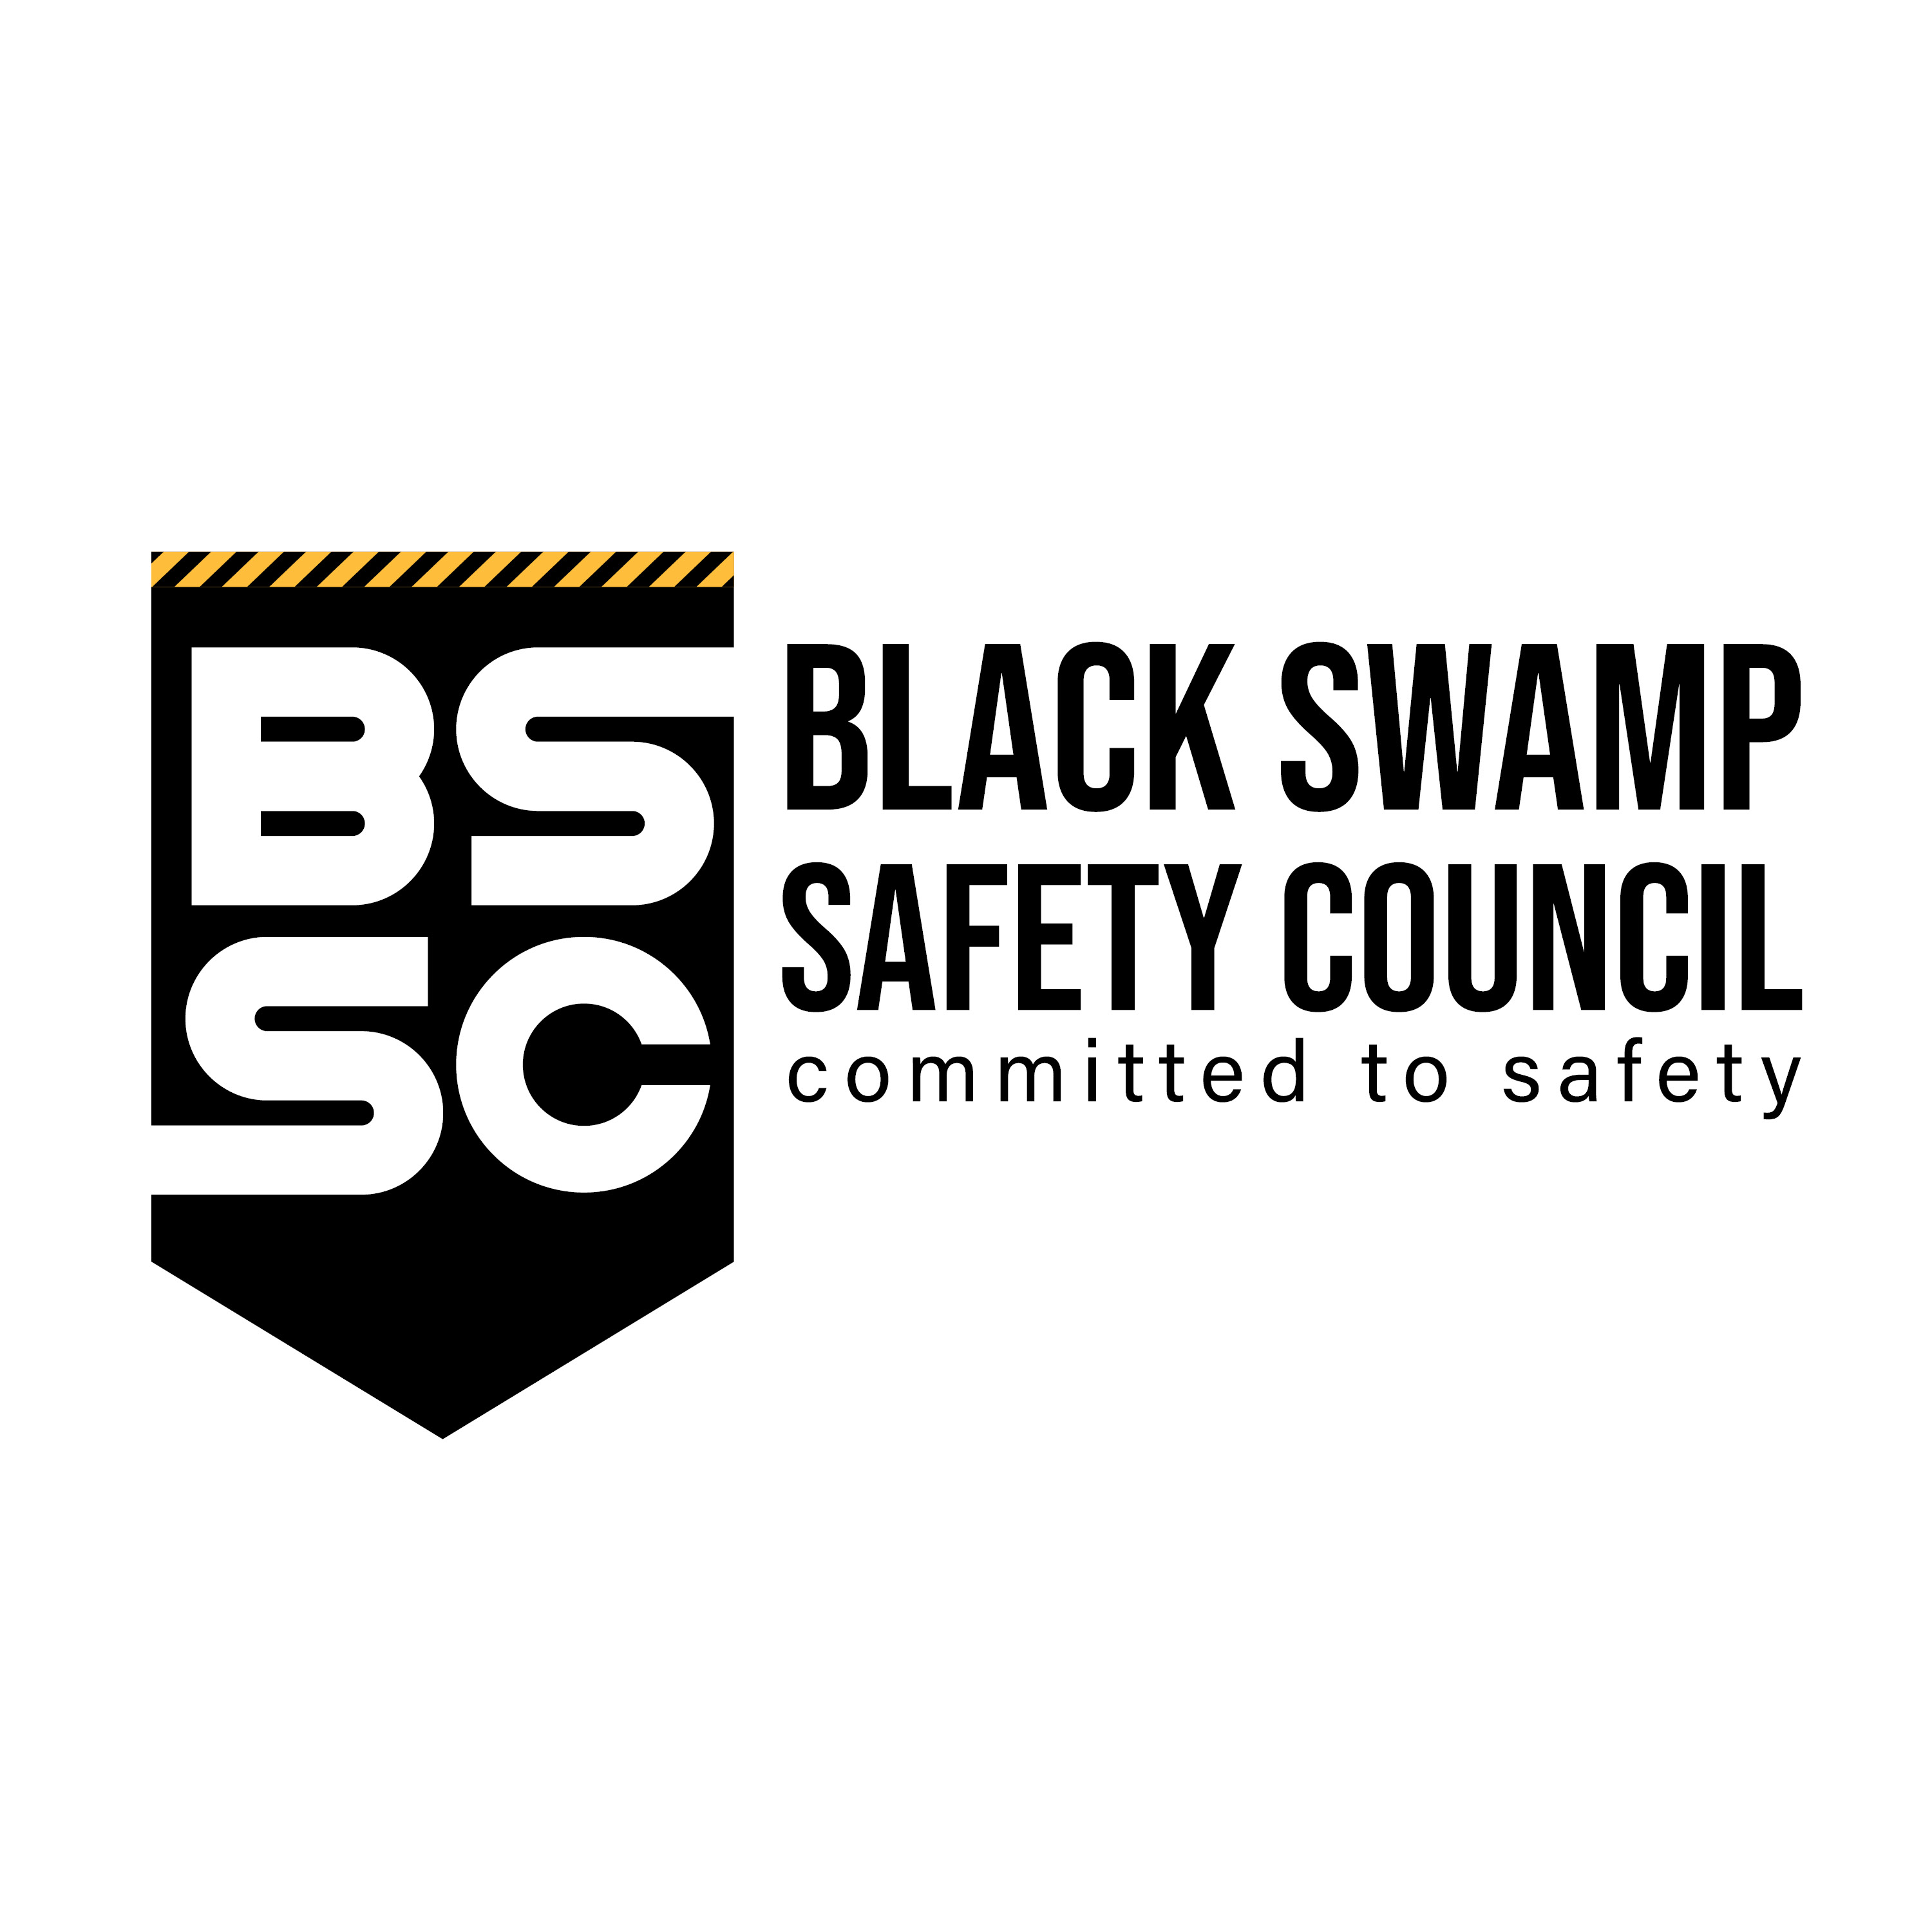

Black Swamp Safety Council
22600 State Route 34
Archbold, Ohio 43502

MEMBER APPLICATION & ENROLLMENT FORM

Date _________________________ BWC Policy Number __________________________________
Company Name ___________________________________________________________________ Address/City, Zip ___________________________________________________________________ Phone Number/Fax Number __________________________________________________________ NAICS Code ______________________________________________________________________ Number of Employees _____________________________________________________________
Type of work your company does ______________________________________________________ Web Site _________________________________________________________________________ Upper Mgmt./CEO & Title ____________________________________________________________
E-Mail Address ____________________________________________________________________
Safety Contact & Title _______________________________________________________________
E-Mail Address ____________________________________________________________________
HR Contact & Title _________________________________________________________________
E-Mail Address ____________________________________________________________________
Accounts Payable Contact ___________________________________________________________
E-Mail Address ____________________________________________________________________
Main Contact Email Address __________________________________________________________ Main Contact Signature ______________________________________________________________

22600 State Route 34 Archbold, OH 43502 Phone: 419-267-1351 Fax: 419-267-5588 E-mail: bssc@northweststate.edu
Revised: 2/03/2026

